FARRAH ELYANIE BT FAUZI (271273)

**Questions:  
• What will be printed?**

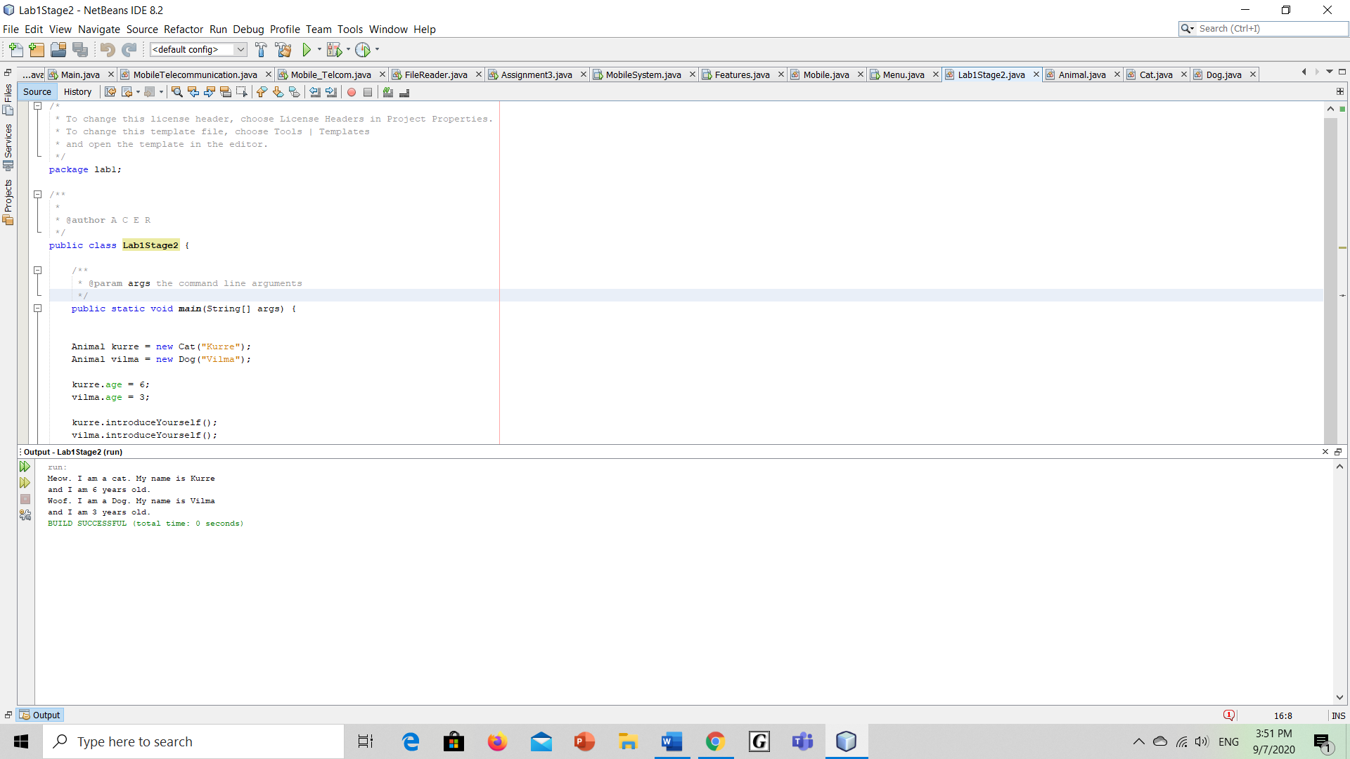  
**• Explain how it is that the instance variable age of Animal can be used in Cat and Dog when it is declared in Animal.**

-because use inheritance that will be inherit/extends all the variable from Superclass which is Animal class to subclass Cat and Dog. So, both classes will have the instance of the Animal class.

**• What actually consists an instance of?**

-Each instance of the class contains its own copy of the variables. Which Variables defined within a class are call instance variable.

**• And what consists a class of?**

- A class contain a blueprint or a template for creating different objects which defines its properties and behaviors. A class can consist of fields and methods to describe the behavior of an object.

**• What is the difference between a class and an instance?**

**-**A class is a blueprint which you use to create objects. An object is an instance of a class - it's a concrete 'thing' that you made using a specific class. So, 'object' and 'instance' are the same thing, but the word 'instance' indicates the relationship of an object to its class.

**• Change the declaration of the instance variable age of Animal to a class variable using static, in this way:  
public static int age;**

**What is the result of the output now? Why?**

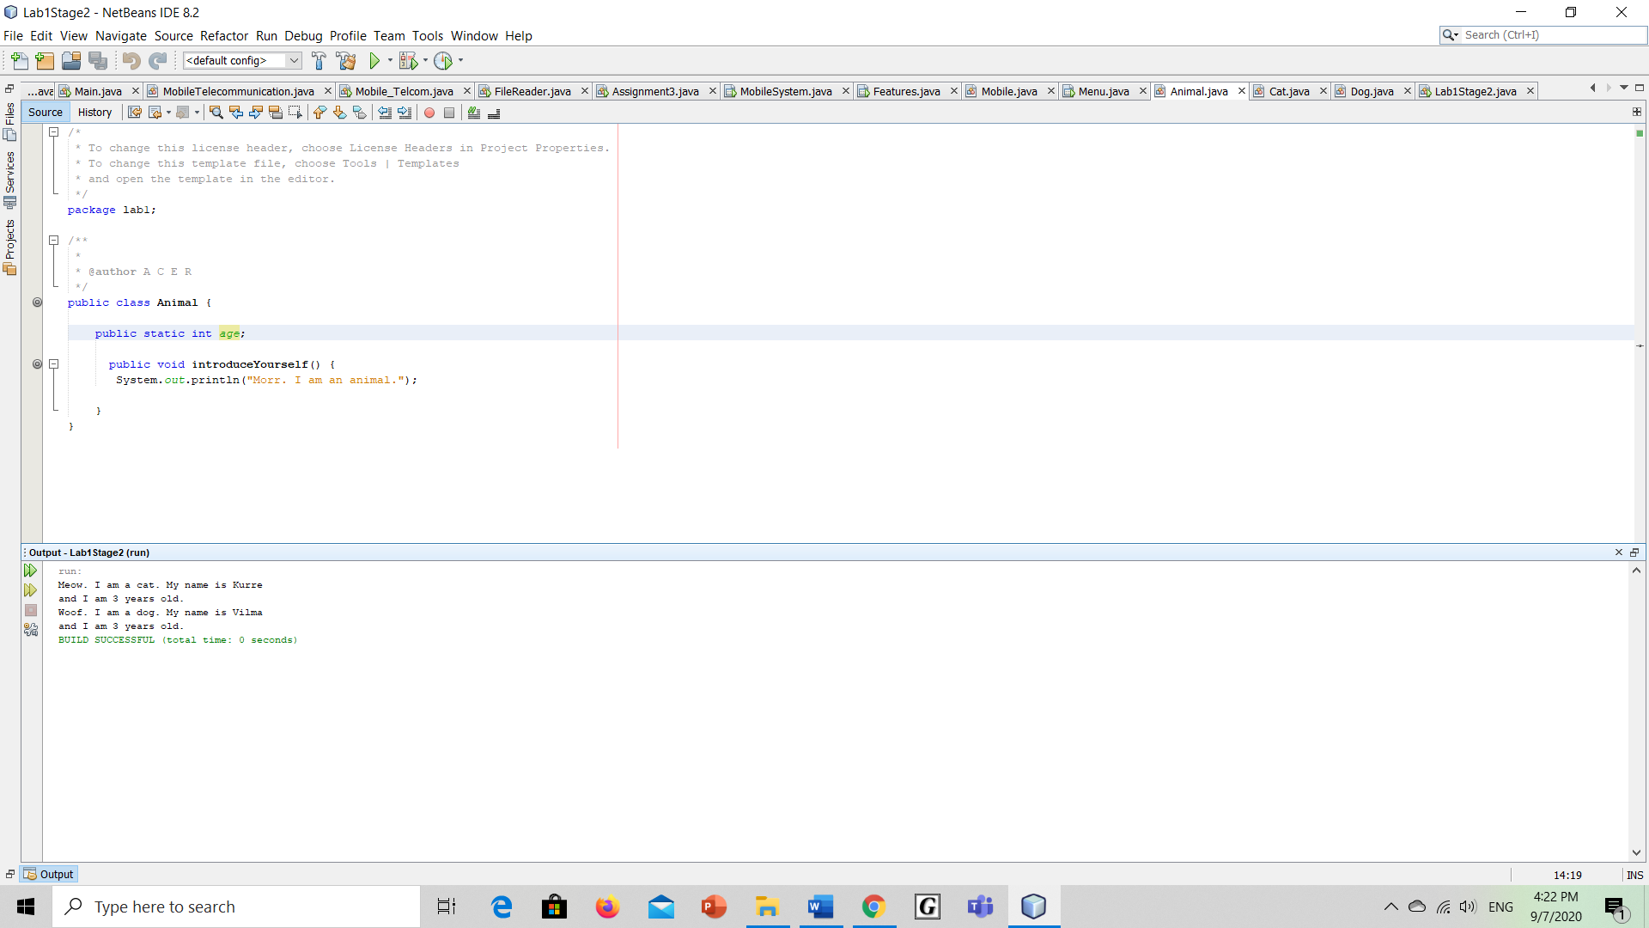

-the output is different because the static field Animal.age should be accessed in a static way. Now the static field is belonging to Animal so the result for both age is 3.

**• It may happen that you get warnings from the compiler that you should access the variable age via Animal.age, but it should be possible to run the program anyway. Otherwise, change the references to age into Animal.age.**

**• Where is the value of an instance variable stored?**

-it will be stored in the class itself where the variable was defined

**• Where is the value of a class variable stored?**

- it will be stored inside a property of the class objects. in this case, the class variable age will be stored in an Animal instance.

**• What refers the variable this to?**

-The keyword this refers to the variable in the class. If two variables have the same name are used, this keyword will make sure the current class version of the two will be used.